**Project report**

Modular tether less baby simulator

Name: Hussam Al-Anesi (635155), Stijn Jans (638172), Alif Widianto (642546)

Academy: HAN (Hogeschool van Arnhem en Nijmegen)

Education: Electrical Engineering (IPS), 3rd grade

Location: Arnhem

Version: 1.0

Date: 10-06-2022  
Pages: 20

# Document history

|  |  |  |  |
| --- | --- | --- | --- |
| **Version** | **Date** | **Author** | **Modification** |
| 1.0 | 10-06-2022 | Hussam Al-Anesi  Alif Widianto  Stijn Jans | First version |

# Summary

This report has been written for perusal of the progress of the 3rd year HBO electrical engineering project of Hussam Al-Anesi, Stijn Jans, and Alif Widianto.   
The Modular Tether less baby simulator is a mannequin intended to improve the CPR training in the field of infant medical health care. The idea is for nursing students to practice CPR on infants using the mannequin in which the mannequin is supposed to monitor and give feedback about compression and ventilation.

**The main task** for the IPS group is to design a reliable charging station which includes rechargeable batteries, protection circuit and buck converters to step down the voltage based on the sensor’s and MCUs rated voltages.

**The main parts** that the system consists of are: batteries, BMS (Battery Management System), fuel gauge and buck converter. The battery serves as the energy storage from which all the electronics are powered. The battery management system ensures the safety of the batteries by protecting the cells from overvoltage, undervoltage, hot or cold conditions, and it ensures that all cells are balanced. The buck converter is the connection between the batteries and the electronics. It is a dual non-synchronous buck converter providing fixed 5.0-V and 3.3-V output at up to 2 A each from a 12-V input bus. The fuel gauge is responsible of reading the state of charge and state of health of the system.

**The main tests** that were conducted are individual and a complete system tests. The individual tests include: validating the cell balancing using the BMS, validating that the output voltage of the BMS equals the input voltage, simulation of the overvoltage, undervoltage and hot conditions of the BMS, measuring the output voltage of the two buck converters (5V and 3.3V), reading the state of charge of the battery cell using the fuel gauge and the adapter. The complete system test includes measuring the output of the two buck converter channels while the system is not being charged, and while it is being charged.

**The test results** show that all the tests passed and showed the expected results, except for the fuel gauge, which worked at first, but later it failed to communicate with the software. It is expected that either the board is damaged, or the software needs to be configured differently with the help of ESE students.

**The topics that can be worked on in the future are**: buying an Adaptor with a DC connector, communicating the fuel gauge with the MCU, adding an ON/OFF Switch, implementing of the buck converter PCB, Reconfiguring the fuel gauge for multi-cell operations, and adding parallel cells if the lifetime of the battery pack needs to be increased.

# Preface

This report has been written for perusal of the progress of the 3rd year HBO electrical engineering project of Hussam Al-Anesi, Stijn Jans, and Alif Widianto.

During this project, we worked 3 days a week, in which we had a stand-up with the client, the ESE and IPO students on Wednesday’s. We had a clear definition since the start of who does what; however, these tasks changed with the progress of the project. For most of the tasks, we brainstormed together and always shared our ideas and findings with each other. The cooperation with the ESE and IPO students from our group was not direct as each of the groups had their own separate tasks and the common point was not reached in this project. Yet, they helped us with advice about configuring the fuel gauge. More cooperation was done with the IPO students from S4 as they were working on implementing the charging circuit with the batteries inside the head.

Even though the learning outcomes do not exactly match the learning outcomes we set at the start of the project, we still enriched our knowledge with various topics, such as the characteristics of and differences between different battery types and their application, protection circuits and their topology such as BMS, state of charge measurements method, improving the behaviour of buck converter using the control system’s theory that we learned, and PCB design.

It was a fun and instructive project because there was a good combination between theory and practice. As soon as components were selected, tests were carried out. What did not go well is the delivery of some components, some of which were delivered later than expected and some which were never delivered. In upcoming projects, we will try to be more independent and manage the orders of the components by ourselves.

We would like to thank everyone who has been involved in the project. We would like to thank in particular Johan Korten (Client) and Jan Geurts van Kessel (Expert). We also would like to thank Johan Brussen (teacher) for his advice.

Table of contents

Document history 2

Summary 3

Preface 4

Figure list 7

Table list 7

1 Introduction 8

2 Report structure 9

2.1 1 Introduction 9

2.2 2 Assignment and current situation 9

2.2 2 Report structure 9

2.3 3 Approach 9

2.4 4 User requirements 9

2.5 5 Functional design 9

2.6 6 Technical design 9

2.7 7 Realisation 9

2.8 8 Testing and test results 9

2.9 9 Conclusion 9

2.10 10 Future work 9

Appendix 9

3 Approach 10

4 User Requirements 11

4.1 Functionality requirements 11

4.2 Usability requirements 11

4.3 Reliability requirements 11

4.4 Performance requirements 11

4.5 Supportability requirements 11

5 Functional design 12

5.1 General system overview 12

6 Technical design 13

6.1 System description 13

6.1.1 Battery and charger 13

6.1.2 BMS 13

6.1.3 Buck converter 14

6.1.4 Fuel gauge 14

6.2 Power consumption and Amps hour 14

6.3 Charging time 14

7 Realisation 15

7.1 Connection of components in realization compared to functional design 15

7.2 Components in realization compared to technical design 15

7.2.1 Buck converter 15

7.2.2 Power supply 15

7.3 Component choice 15

8 Testing and test results 16

8.1 Individual tests: 16

8.2 Complete system test: 16

8.3 Tests results and conclusion: 16

9 Conclusion 17

10 Future work 18

10.1 Adaptor 18

10.2 MCU 18

10.3 Switch 18

10.4 DC connector 19

10.5 Implementation of the buck converter PCB 19

10.6 Soft start-up and shut-down 19

10.7 Reconfiguring the fuel gauge for multi-cell operations 19

10.8 Lifetime of battery pack 20

10.9 Charging time of battery pack 20

# Figure list

[Figure 1: V Model 11](https://hannl-my.sharepoint.com/personal/s_jans3_student_han_nl/Documents/Chatbestanden%20van%20Microsoft%20Teams/Modular%20Tetherless%20baby%20simulator.docx#_Toc105679522)

Figure 2: General schematic of the system 13

[Figure 3: Cell, NCR16850B 14](https://hannl-my.sharepoint.com/personal/s_jans3_student_han_nl/Documents/Chatbestanden%20van%20Microsoft%20Teams/Modular%20Tetherless%20baby%20simulator.docx#_Toc105679524)

[Figure 4: Battery charger 14](https://hannl-my.sharepoint.com/personal/s_jans3_student_han_nl/Documents/Chatbestanden%20van%20Microsoft%20Teams/Modular%20Tetherless%20baby%20simulator.docx#_Toc105679525)

[Figure 5: BMS, BQ77915EVM-014EVM 14](https://hannl-my.sharepoint.com/personal/s_jans3_student_han_nl/Documents/Chatbestanden%20van%20Microsoft%20Teams/Modular%20Tetherless%20baby%20simulator.docx#_Toc105679526)

[Figure 6: Buck converter, TPS54386EVM 15](https://hannl-my.sharepoint.com/personal/s_jans3_student_han_nl/Documents/Chatbestanden%20van%20Microsoft%20Teams/Modular%20Tetherless%20baby%20simulator.docx#_Toc105679527)

[Figure 7: Fuel gauge, BQ34Z100EVM 15](https://hannl-my.sharepoint.com/personal/s_jans3_student_han_nl/Documents/Chatbestanden%20van%20Microsoft%20Teams/Modular%20Tetherless%20baby%20simulator.docx#_Toc105679528)

[Figure 8: Setup of complete system 16](https://hannl-my.sharepoint.com/personal/s_jans3_student_han_nl/Documents/Chatbestanden%20van%20Microsoft%20Teams/Modular%20Tetherless%20baby%20simulator.docx#_Toc105679529)

[Figure 9: Schematic of complete system 16](https://hannl-my.sharepoint.com/personal/s_jans3_student_han_nl/Documents/Chatbestanden%20van%20Microsoft%20Teams/Modular%20Tetherless%20baby%20simulator.docx#_Toc105679530)

[Figure 10: Buck converter, LM2596 16](https://hannl-my.sharepoint.com/personal/s_jans3_student_han_nl/Documents/Chatbestanden%20van%20Microsoft%20Teams/Modular%20Tetherless%20baby%20simulator.docx#_Toc105679531)

# Table list

Table 1: Functionality Requirements 14

Table 2: Usability Requirements 14

Table 3: Reliability Requirements 14

Table 4: Performance Requirements 14

Table 5: Supportability Requirements 14

# 1 Introduction

The Modular Tether less baby simulator is a mannequin intended to improve the CPR training in the field of infant medical health care. The idea is for nursing students to practice CPR on infants using the mannequin in which the mannequin is supposed to monitor and give feedback about compression and ventilation. The Mannequin is equipped with sensors and microcontroller units; however, these electronics are still not powered.

The main task for the IPS group is to design a reliable charging station which includes rechargeable batteries, protection circuit and buck converters to step down the voltage based on the sensor’s and MCUs rated voltages. All the design was done based on research, and consultation with the experts. The previous documentation from last year’s S6 students was not used since their design is based on ICs that are not on stock.

This report explains the process of designing the charging station, and the choice reasoning of all the ordered components. It shows how the system is designed using a block diagram, and how the design is compared to the actual realization. Furthermore, it illustrates the requirements set, and compares them with the final results. Finally, it provides recommendation for future work that needs to be done to improve the prototype.

2 Report structure  
In this section, the logical structure of the chapters with the corresponding subject will be discussed. The structure is as follows:

## 2.1 1 Introduction

The introduction briefly explains the task of the project, and what the report is about.

## 2.2 2 Assignment and current situation

In this chapter the assignment and the status of the current situation of the supplied system at that time is described. It also describes which problem must be tried to solve and which goals are pursued.

## 2.2 2 Report structure

The chapter ‘Report structure’ describes the structure of the report.

## 2.3 3 Approach

The ‘Approach’ chapter describes the approach of the project.

## 2.4 4 User requirements

The chapter ‘User requirements’ describes what is in the ‘Plan of Requirements’.

## 2.5 5 Functional design

In the chapter ‘Functional design’ the system is described. It describes what the system should do and how the user sees the system.

## 2.6 6 Technical design

The architecture and global solution are described in the ‘Technical design’ chapter.

## 2.7 7 Realisation

The chapter ‘Realisation’ explains how the prototype looks like.

## 2.8 8 Testing and test results

The chapter ‘Testing and test results’ shows how the hardware and software has been tested and what the results of the tests are

## 2.9 9 Conclusion

The chapter ‘Conclusion and recommendations’ discuss what has been achieved and what has not been achieved and what recommendations are made to improve the product.

## 2.10 10 Future work

The chapter ‘Future work’ explains what work needs to be done in the for a finally working system

## Appendix

The corresponding attachments can be found here, calculations and tables.

# 3 Approach

This chapter discusses the method by which the project was completed. During this project a few approaches are used. The approaches that are used during this project are Agile, and   
V-Model.  
  
3.1 Agile  
During this project a method that is used is an Agile method named Scrum. The essence of this approach is to split the project into smaller tasks named sprints. The sprints in which this project is divided are *Battery, Charger, BMS (Battery Management System), Fuel gauge, and Buck converter.*

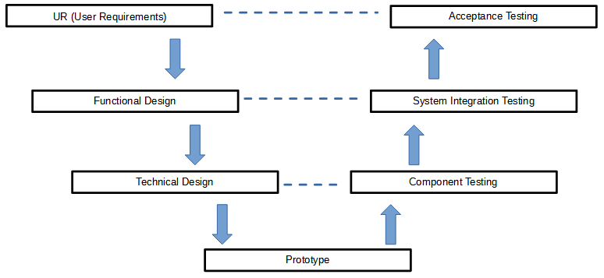  
3.2 V-Model  
The V-Model used is shown in *Figure 1 V Model.* When using the V-Model, the project is divided into phases that each containing a number or predefined products. The phases in which the V-Model is divided are *UR (User Requirements), Functional Design, Technical Design, Prototype, Component testing, System Integration Testing, and Acceptance Testing.*

Figure 1: V Model

# 4 User Requirements

Requirements must be drawn up in order to be able to test whether the final solution meets the requirements. These requirements have been drawn up in consultation with the end users and can be discussed. The wishes of the end user are also included in this. An important part of drawing up new requirements is looking at what needs to be considered from the current situation.  
After looking at the current situation, the Plan of Requirements has been drawn up. The Plan of Requirements has been drawn up considering the non-negotiable restrictions enforced by the customer.   
The requirements are divided into 5 categories, namely: *Functionality, Usability, Reliability, Performance, Supportability.*

## 4.1 Functionality requirements

|  |  |  |
| --- | --- | --- |
| **Nr.** | **Description** | **MoSCoW** |
| 1. | The system must be powered by a rechargeable battery. | Must have |
| 2. | The system is usable while the batteries are being charged. | Could have |
| 3. | The system must have a smooth start up and shut down. | Must have |

Table 1: Functionality Requirements

## 4.2 Usability requirements

|  |  |  |
| --- | --- | --- |
| **Nr.** | **Description** | **MoSCoW** |
| 1. | The system includes a power button to turn On or OFF the system. | Must have |
| 2. | The system is user-friendly with plug/power connection. | Must have |

Table 2: Usability Requirements

## 4.3 Reliability requirements

|  |  |  |
| --- | --- | --- |
| **Nr.** | **Description** | **MoSCoW** |
| 1. | The system consists of a thermal protection. | Must have |
| 2. | The system consists of an under/over current protection. | Must have |
| 3. | The system consists of a wrong polarity protection. | Must have |
| 4. | The system consists of a peak voltage protection. | Must have |
| 5. | The state of charge must be measured. | Must have |

Table 3: Reliability Requirements

## 4.4 Performance requirements

|  |  |  |
| --- | --- | --- |
| **Nr.** | **Description** | **MoSCoW** |
| 1. | The battery life is 8 hours. | Wish |
| 2. | The system is charged by means of fast battery charging. | Could have |
| 3. | The system consists of a wireless charging | Won’t have |

Table 4: Performance Requirements

## 4.5 Supportability requirements

|  |  |  |
| --- | --- | --- |
| **Nr.** | **Description** | **MoSCoW** |
| 1. | The system can use external charging (for example micro-b or USB-C) or changeable battery. | Wish |

Table 5: Supportability Requirements

# 5 Functional design

This chapter explain **what** the system can do. It gives an overview of all the separate blocks of the system and shows the connection between the blocks to form a complete system.

## 5.1 General system overview

The general overview is shown in the figure below. In this illustration, the charger is connected to the positive and negative terminal of the BMS pack. Each cell of the battery pack is connected to the BMS, and the BMS output is then connected to the buck converter, which supplies the load. The positive and negative terminals of the battery pack is connected to the fuel gauge. The fuel gauge is then connected to the MCU. A switch is added before the buck converter to allow the user to switch ON and OFF the supply to the load.

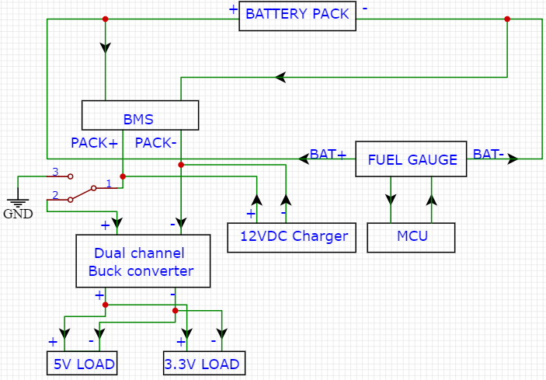

Figure 2: General schematic of the system

# 6 Technical design

This chapter explains **how** the system blocks work. It gives an overview of all the separate blocks of the system. Also, the total power consumption calculation is written.

## 6.1 System description

The system consists of four main parts: batteries, BMS, fuel gauge and buck converter. In this section, the functionality of each of them is explained.

### 6.1.1 Battery and charger

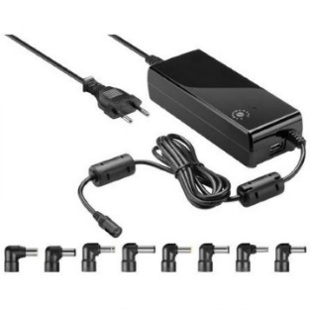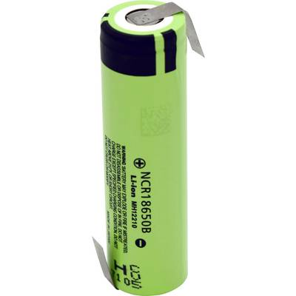The battery serves as the energy storage from which all the electronics are powered. In this system, three Li-Ion batteries are connected in series, which supplies 12V to the buck converter input. The choice of the battery is made after comparing different types of medical-applications batteries, and with consultation with the client. The capacity of each cell equals 3.4Ah. Based on the total power consumption calculation is appendix A, the maximum capacity required to run the system for one cycle (4 hours) is 3Ah; therefore, these 3.4Ah cells are sufficient. The battery charger is a 12VDC 4A adapter, which allows using the system while charging. The high current rating of the adapter charges the batteries fast.

Figure 3: Cell, NCR16850B

Figure 4: Battery charger

### 6.1.2 BMS

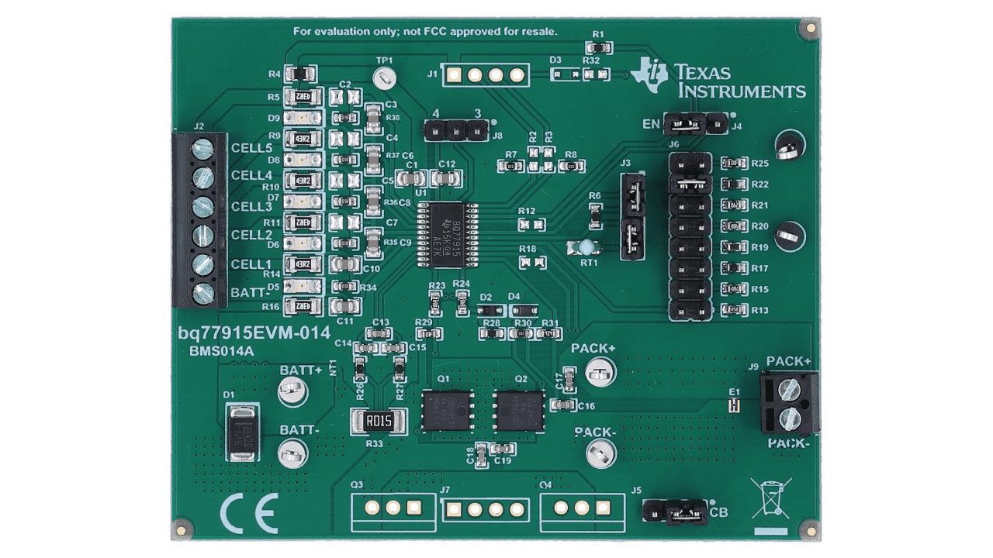The battery management system ensures the safety of the batteries by protecting the cells from overvoltage, undervoltage, hot or cold conditions, and it ensures that all cells are balanced. The BQ77915EVM-014 evaluation module from TI is used in this system. This EVM includes one BQ77915 and FETs to control current in a configuration typical for switching current in a lithium-ion battery pack. The circuit module includes one BQ77915 integrated circuit (IC), a sense resistor, a thermistor, two FETs, and all other onboard components necessary to switch charge and discharge current.

Figure 5: BMS, BQ77915EVM-014EVM

### 6.1.3 Buck converter

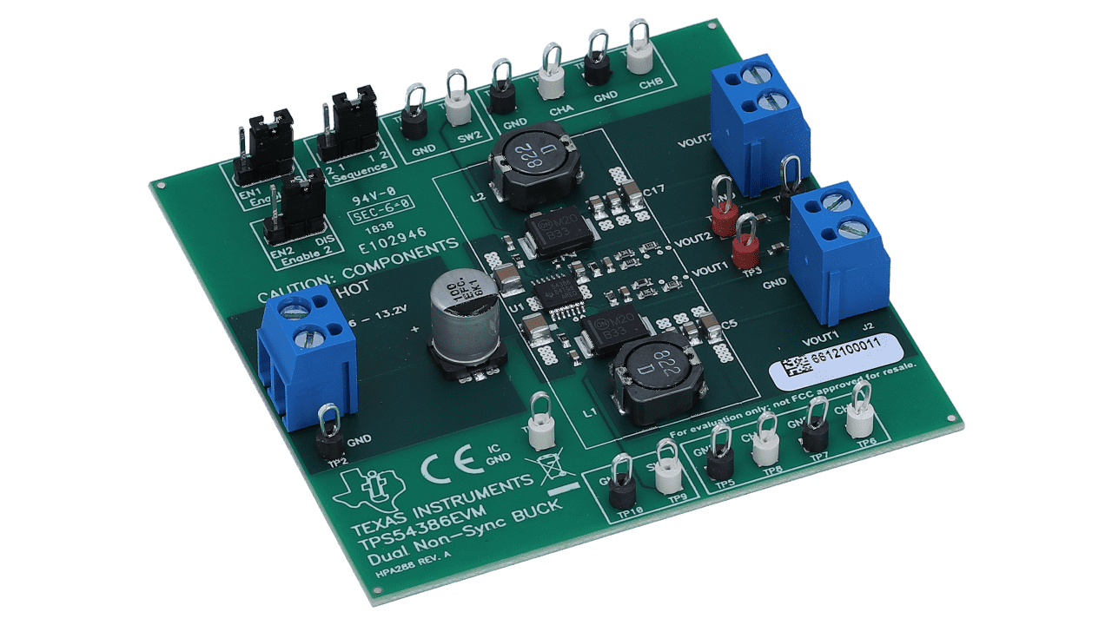The buck converter is the connection between the batteries and the electronics. The TPS54386EVM evaluation module (EVM) is used in this system. It is a dual non-synchronous buck converter providing fixed 5.0-V and 3.3-V output at up to 2 A each from a 12-V input bus. This converter is sufficient as all the sensors and electronics in the system have a rating of 3.3V or 5V. This converter includes the soft starting feature.

Figure 6: Buck converter, TPS54386EVM

### 6.1.4 Fuel gauge

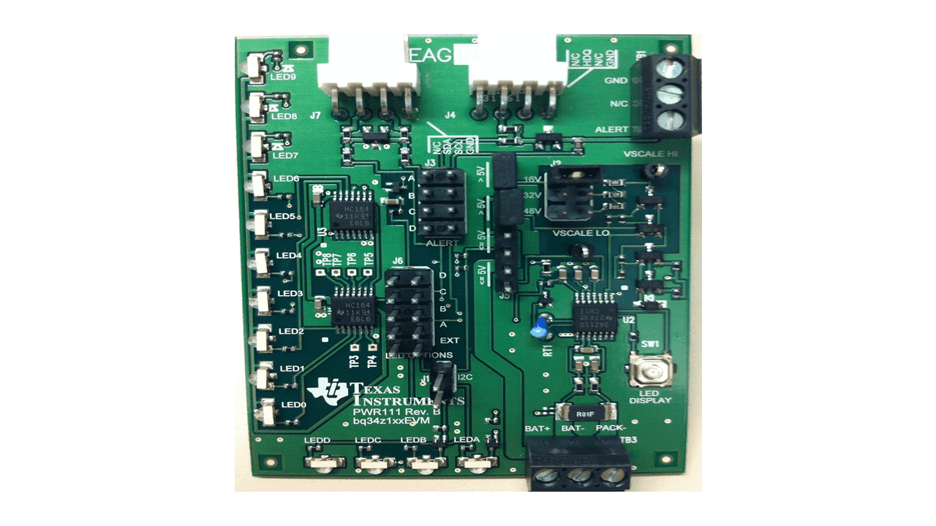The fuel gauge is responsible of reading the state of charge and state of health of the system. This evaluation module (bq34z100EVM) is a complete evaluation system for the bq34z100 wide range fuel gauge for lithium-ion chemistries when combined with an EV2400 USB adapter and Windows™-based PC software downloadable from the TI.com website. The circuit module includes one bq34z100 integrated circuit (IC) and all other components necessary to monitor and predict capacity in 1 or more series cell Li-ion.

Figure 7: Fuel gauge, BQ34Z100EVM

## 6.2 Power consumption and Amps hour

The total power consumption is calculated to determine the battery capacity required to have the system working for at least 4 hours, and to find the total output current to choose a charger with higher current, allowing the system to be used while charging. Refer to appendix A for the calculation.

Based on the calculation, the nominal capacity required to run the system for one cycle (4 hours) is 3Ah, and the maximum capacity is 3.52. Therefore, the selected 3.4Ah Li-ion cells are sufficient. Furthermore, the maximum total output current is 2.59A; thus, the selected 4A charger is sufficient.

## 6.3 Charging time

The total time to charge the batteries using the 4A adapter is calculated simply based on the current rating of the adapter and the battery’s capacity. This results in a total time of 51 minutes, as shown below:

$$Charge time (minutes)=\frac{Capacity (Ah)}{Current (A)}×60$$

$$Charge time=\frac{3.4}{4}×60=51 minutes$$

# 7 Realisation

This chapter explain how the prototype is realized, how the components are connected and what components are used compared to the functional and technical design.

## 7.1 Connection of components in realization compared to functional design

* In the realisation instead of a charger, a 12VDC power supply is used. The power supply is connected to the positive and negative terminals of the BMS pack.
* In realization, each cell of the battery pack is connected to the BMS.
* The BMS output is connected to two separate buck converters instead of a dual buck converter, which supplies the load.
* Instead of connecting the fuel gauge to the positive and negative terminals of the battery pack, the fuel gauge is connected to only one cell. This can be justified due to the balancing of the cells, meaning that each cell holds the same state of charge.
* 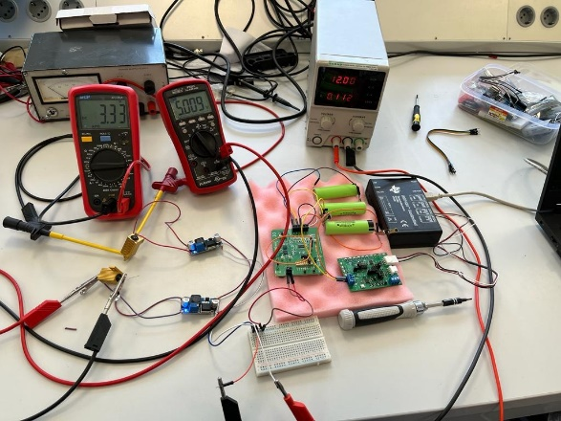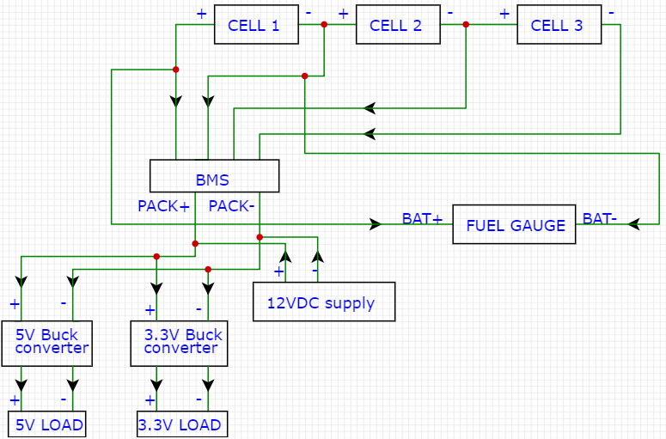In the realisation no switch and no MCU are connected.

Figure 8: Setup of complete system

Figure 9: Schematic of complete system

Figure 7.1 Test Connection of the system

## 7.2 Components in realization compared to technical design

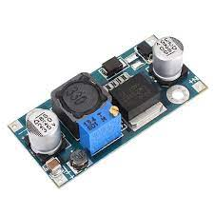Components that do not match the technical design:

7.2.1 Buck converter  
Due delivery problems, there is chosen to use a buck converter that was in stock at the HAN. The buck converter that is used at the moment is the LM2596. The LM2596 provides an adjustable output of 3.3V, 5V, 12V and an 3A output load current. It has an input voltage range up to 40V.

Figure 10: Buck converter, LM2596

7.2.2 Power supply   
Due delivery problems, there is chosen to use a power supply because these were available at the HAN.

## 7.3 Component choice

For process of the components choices see the appendix B.

# 8 Testing and test results

Several tests were carried out to prove the functionality of the system, this includes testing the components individually and testing it as a whole system. The specific steps, results and conclusion for each test are described in document “testing and testresults”.

## 8.1 Individual tests:

The individual tests include: validating the cell balancing using the BMS, validating that the output voltage of the BMS equals the input voltage, simulation of the overvoltage, undervoltage and hot conditions of the BMS, measuring the output voltage of the two buck converters (5V and 3.3V), reading the state of charge of the battery cell using the fuel gauge and the adapter.

## 8.2 Complete system test:

The complete system test includes testing the system when it is not charged and testing the whole system while it is being charged. For each of the two tests, the output voltage of the two buck converter channels is measured, and the state of charged is read using the fuel gauge and the adapter.

## 8.3 Tests results and conclusion:

The test results of the individual tests are all **Passed**, and can be concluded as follows:

* The battery cells are balanced when connected to the BMS.
* The input and output voltage of the BMS are the same.
* In case of an overvoltage, the voltage over the pack terminals of the BMS drops to 600mV below the supply voltage.
* In case of undervoltage, hot or cold condition, the voltage over the pack terminals of the BMS drops to 0V.
* The output of the first buck converter equals 5V and the second buck converter quals 3.3V.
* The state of charge of one battery cell is read in the software.

The test results of the complete system are all **Passed**, except for the fuel gauge measurement, the results are as follows:

* The value of the first and second buck converter are measured as 5V and 3.3V respectively while the system is not being charged.
* The value of the first and second buck converter are measured as 5V and 3.3V respectively while the system is being charged.
* The software could not read the value of the battery cell anymore, even when the battery cells are not connected to the rest of the system. This could mean that the fuel gauge board is damaged.

# 9 Conclusion

The initial goal of this project was to design a reliable charging station capable of powering all the sensors and microcontrollers inside the baby. The final result was building a working prototype that meets most of the requirements. A summary of the results based on MoSCoW requirements is shown in appendix C.

**Battery and charger:**

* 3 Li-ion cells are used in this system with a capacity of 3.4Ah.
* Based on calculation, the batteries should last for a minimum of 4 hours while the system is used.
* The system can be used while the batteries are being charged.
* The charger selected should charge the batteries in around 51 minutes based on calculation.

**Protection:**

* A BMS is used in this system, which ensures cell balancing, over/under voltage protection, over/under current protection, hot/cold conditions.

**Starting and shutting down the system:**

* The current prototype does not include a soft start and shutdown feature.
* A buck converter PCB was designed, which ensures soft start and shutdown, eliminated noise and ringing effect, but was not implemented in the system due to time constrains.
* A switch is not included yet in the current prototype; however, the block diagram in section 5 shows how it should be connected.

# 10 Future work

This chapter explains the future work that is required to improve and finalize the prototype. In this project, a working prototype has been designed; however, it is not yet implemented inside the baby. The future work that needs to be carried out is explained in the following subchapters.

## 10.1 Adaptor

At the moment a power supply is used to simulate an adaptor. To get a complete working system an adaptor will have to be ordered. The specification that the adapter must meet are AC/DC adaptor:  
- Input voltage 100-240V  
- Output voltage 12V  
- Output current 3Aor 4A

Possible options for the adaptor are:

* 12VDC 3A adapter: <https://www.allekabels.nl/ac-dc-adapter/7207/1307583/universele-ac-dc-adapter-12-v.html>
* 12VDC 4A adapter: <https://www.allekabels.nl/ac-dc-adapter/7207/1297142/laptop-adapter-universeel.html>

Both options allow using the system while charging; however, the 4A adapter charges the system faster.

## 10.2 MCU

A microcontroller unit is essential to read receive the state of charge measurements from the fuel gauge and display it for the user. Due to time constrains, a MCU is not used in this project; rather, the measurements are read by connecting the fuel gauge to a PC using an adapter.

Possible options for MCU units to be used in the future are:

* Arduino UNO: <https://www.reichelt.nl/nl/nl/arduino-uno-rev-3-atmega328-usb-arduino-uno-p119045.html?PROVID=2809&gclid=CjwKCAjwkYGVBhArEiwA4sZLuI9_ZUNfaiEaIsx-3Qaojzv0_eCC1RIsw-425pjZStA3SoqGmA1paBoCmgQQAvD_BwE>
* Raspberry Pi 4 model B: <https://www.reichelt.nl/nl/nl/raspberry-pi-bereken-module-4-io-board-rpi-cm4-io-board-p290556.html?PROVID=2809&gclid=CjwKCAjwkYGVBhArEiwA4sZLuL5Ys6QnUVX2KxBzXtWvkV2KWMS3SBv4IGKLt47zb9JG5xI5tsWP9BoCrD8QAvD_BwE>

## 10.3 Switch

The system must also be able to be switched on and off. Because of this a switch has to be implemented in the system. When selecting a switch make sure that the switch can handle at least 12VDC and 4A. The switch needs to be connected before the buck converter to ensure that the Buck converter channels apply smooth start every time the system is turned ON, as shown in figure 2.

Possible option for a switch is:

* 12VDC, 10A max switch: <https://www.allekabels.nl/schakelaar/7303/1198346/tuimelschakelaar.html?gclid=CjwKCAjwp7eUBhBeEiwAZbHwka60ebxaV7_KeaDAJVsf9W0h9s20XYfJ9x9CPLgFX4QvKscFwFJgNRoCyQcQAvD_BwE>

## 10.4 DC connector

To ensure that the adapter can be connected to the system a DC connector must be added to the system. When selecting the connector, make sure that the plug size outside and inside diameter meets the requirements of the adapter and vice versa

A possible option for the DC connector is:

* DC plug female: <https://www.allekabels.nl/ac-dc-adapter/7207/1217090/voedingsstekker-naar-schroefaansluiting.html>

## 10.5 Implementation of the buck converter PCB

A PCB board of a buck converter with an IC TPS54286 was designed, but not used for this prototype due to the time constrains. This PCB offers more reliability and better features than the buck converter used in the prototype, such as: less output noise, soft start and controlled enable channels. Furthermore, before using the PCB board, the board has to be tested using the test points. A complete test plan and procedures is provided in the TI’s user guide of the EVM-TPS54386 [TPS54x86 Step-Down Converter Evaluation Module User's Guide (Rev. A)](https://www.ti.com/lit/ug/sluu286a/sluu286a.pdf?ts=1654706632594&ref_url=https%253A%252F%252Fwww.ti.com%252Ftool%252FTPS54386EVM)

The designed PCB can be found in the attached document (Buck converter schematics calculations and PCB design).

## 10.6 Soft start-up and shut-down

To protect the microcontroller and the raspberry pi from sudden rise and drop of voltages a soft start up and shut down has to be implemented. To ensure this, only the 3.3V channel must be enabled first. The microcontroller is connected to this channel. The microcontroller will then read the state of charge of the battery. When the state of charge is more than 20%, also the 5V channel will be enabled. The smooth start is already implemented in the PCB. A soft shut down has to be implemented as well. Soft shut down implementation guide can be found in the following link: <https://www.ti.com/lit/an/slvaey9/slvaey9.pdf?ts=1654209559268&ref_url=https%253A%252F%252Fwww.google.com%252F>

## 10.7 Reconfiguring the fuel gauge for multi-cell operations

During the tests, the gauge could read a single cell battery perfectly, both when tested separate from the whole system and when connected to the system. However, during the last test, the software could not detect any communication with the board, either when connecting the cell separately or when the battery is connected to the rest of the system.

**Possible problems:**

* Board damage/dead.
* Software configuration.

**Next Steps**:

* Test the board by connecting a power supply to it and see if the LED lights up.
* Test the i2c communication interface with an Arduino or Raspberry Pi.
* Configure the Gauge for a multi-cell operation and connect the fuel gauge across the three batteries. This should be done in cooperation with ESE student due to the complexity of the programming.
* Should the board be damaged, a new one could be acquired via the link on the BOM.

## 10.8 Lifetime of battery pack

The lifetime of the battery pack at the moment is 4 hours. The wish is that the lifetime is 8 hours. To realize this, three series-connected batteries can be connected in parallel to the current battery pack. If this is not an option due the lack of space, new batteries must be selected.

## 10.9 Charging time of battery pack

The charging time of the battery pack at the moment is 51 minutes. As soon as the battery pack is expanded so that it lasts 8 hours the charging time will become 102 minutes. When the battery pack is expanded, the pack can be charged with a max of 8A. When the expanded battery pack is charged with 8A, the charging time will drop to 51 minutes. This is the fasted charging time that can be achieved with these batteries. If the battery pack needs to be charged faster, batteries with a higher current rating should be considered.

**Appendix A: Power consumption and Amps hour calculation**

|  |  |  |  |
| --- | --- | --- | --- |
| 5V |  | 3.3V |  |
| Component | Current consumption(A) | Component | Current consumption(A) |
| Raspberry Pi Zero W2 | 0.8 | SAMD21 | 0.15 (X5) |
| SFM3400 | 0.5 // 0.1 | SAMD51 | 0.25 nominal, 0.5 max |
| QRE1113 | 0.02 max (X16) nom (X8) | DS-0365 | 0.0025 (X3) |
|  |  | SDP810 | 0.0055 |
|  |  | Head tilting sensors | 0.0005 (X4) |
|  |  | NRF52840 | 0.1 |
| **Nominal consumption** | 1.06 | **Nominal consumption** | 1.115 |
| **Max consumption** | 1.22 | **Max consumption** | 1. 365 |

*Table 1: Power consumption*

**Nominal:**

$$5V×1.06=5.3W$$

$$3.3V×1.115A=3.68W$$

$$total power=7.3+5=8.98W$$

$$Primary current=\frac{total power}{Primary voltage}=\frac{8.98}{12}=0.75A$$

$$Amps hour=0.75×4=3Ah$$

**Maximum**

$$5V×1.22A=6.1W$$

$$3.3V×1.365A=4.5W$$

$$total power=6.1+4.5=10.6W$$

$$Primary current=\frac{total power}{Primary voltage}=\frac{10.6}{12}=0.88A$$

$$Amps hour=0.88×4=3.52Ah$$

**Appendix B: Component choice**

**Battery**

1. The first choice of battery went to a LiPo battery because these type of batteries are often used in medical equipment and are relatively cheap.
2. Because no suitable size of a LiPo battery could be found, there is switched to Li-Ion cells. The Li-Ion cells are smaller and can be positioned as desired.

**Charger**

1. The first charger is chosen according to the specifications of the battery.
2. Because a new type of battery is chosen, a new charger is also needed. This is because the charger is only suitable for LiPo batteries. The following charger is chosen because it is suitable for different types of batteries and it has cell balancing so the cells can be safely charged without BMS when tested.
3. As soon as the cells were connected to the BMS, the charger could not be used. This because the BMS conflicts with the cell balancing in the charger. Because there are power supplies at the HAN which are sufficient for tests to be carried out, it was decided to use them during this period.
4. For the relevant purpose, power supplies are not user-friendly. That’s why the advice to use a suitable adapter.

**Fuel Gauge**

1. Firstly, a fuel gauge IC was purchased to determine, among other things, the state of charge, etc.
2. The intention was to make a corresponding PCB from the IC, but when reading the datasheet, it was found out that there were evaluation boards available. Because the board met all the requirements for testing and it saved time, it was decided to order it.

**BMS**

1. Firstly, a BMS IC was purchased, among other things, for the charging and discharging of the battery, etc.
2. The intention was to make a corresponding PCB from the IC, but when reading the datasheet, it was found out that there were evaluation boards available. Because the board met all the requirements for testing and it saved time, it was decided to order it.

**Buck converter**

1. Firstly, a dual channel buck converter was purchased because it is one buck converter with a 3.3V and a 5V output.
2. Because the dual channel buck converter was not delivered, it was decided to use two separate buck converters that were in stock at the HAN.

**Appendix C: Requirements vs results**

**Functionality requirements**

|  |  |  |  |  |
| --- | --- | --- | --- | --- |
| **Nr.** | **Description** | **MoSCoW** | **Final result** | **Pass /fail** |
| 1. | The system must be powered by a rechargeable battery. | Must have | 3 rechargeable Li-ion cells are used. | Pass |
| 2. | The system is usable while the batteries are being charged. | Could have | The BMS chosen can power the system while charging | Pass |
| 3. | The system must have a smooth start up and shut down. | Must have | The buck converter used in the prototype does not include this feature; however, this feature is included in the self-designed PCB. | Fail |

*Table 2: Functionality requirements*

**Usability requirements**

|  |  |  |  |  |
| --- | --- | --- | --- | --- |
| **Nr.** | **Description** | **MoSCoW** | **Final result** | **Pass /fail** |
| 1. | The system includes a power button/switch to turn On or OFF the system. | Must have | A switch was not added to the realised prototype due to delivery problems; however, the block diagram in section 5 indicates how the switch should be connected. | Fail |
| 2. | The system is user-friendly with plug/power connection. | Must have | It was decided to use a female header as a plug for the charger; however, this component was not delivered due to delivery problems. | Fail |

*Table 3: Usability requirements*

**Reliability requirements**

|  |  |  |  |  |
| --- | --- | --- | --- | --- |
| **Nr.** | **Description** | **MoSCoW** | **Final result** | **Pass /fail** |
| 1. | The system consists of a thermal protection. | Must have | The BMS ensures thermal protection from hot and cold conditions | Pass |
| 2. | The system consists of an under/over current protection. | Must have | The BMS ensures under/over current protection. | Pass |
| 3. | The system consists of a wrong polarity protection. | Must have | The BMS ensures polarity protection. | Pass |
| 4. | The system consists of a peak voltage protection. | Must have | The BMS ensures peak voltage protection. | Pass |
| 5. | The state of charge must be measured. | Must have | The fuel gauge read the state of charge in the first tests; however, at a later stage the board did not work. | Fail |

*Table 4: Reliability requirements*

**Performance requirements**

|  |  |  |  |  |
| --- | --- | --- | --- | --- |
| **Nr.** | **Description** | **MoSCoW** | **Final result** | **Passed/failed** |
| 1. | The battery life is 8 hours. | Wish | The batteries used in the system and the series connection last for around 4 hours. | Fail |
| 2. | The system is charged by means of fast battery charging. | Could have | Based on calculation, the batteries would take around 51 minutes to charge. | Fail |
| 3. | The system consists of a wireless charging | Won’t have | The system is designed to be charged with wire. | Pass |

*Table 5: Performance requirements*

**Supportability requirements**

|  |  |  |  |  |
| --- | --- | --- | --- | --- |
| **Nr.** | **Description** | **MoSCoW** | **Final result** | **Pass /fail** |
| 1. | The system can use external charging (for example micro-b or USB-C) or changeable battery. | Wish | The system was designed to use a normal plug with a female header. | Fail |

*Table 6: Supportability requirements*

**Appendix D: Datasheets & User Guides**

**Datasheets**

1. TI BQ7791502PW (BMS IC) : [BQ77915 3-Series to 5-Series Stackable Ultra-Low Power Primary Protector with Autonomous Cell Balancing and HIBERNATE Mode datasheet (Rev. J) (ti.com)](https://www.ti.com/lit/ds/symlink/bq77915.pdf?ts=1654637981657&ref_url=https%253A%252F%252Fwww.google.be%252F)
2. TI BQ34Z100PW-G1 (Fuel Gauge IC) : [BQ34Z100-G1 Wide Range Fuel Gauge with Impedance Track™ Technology datasheet (Rev. D) (ti.com)](https://www.ti.com/lit/ds/symlink/bq34z100-g1.pdf?ts=1654678681328&ref_url=https%253A%252F%252Fwww.ti.com%252Fproduct%252FBQ34Z100-G1)
3. TI TPS54386 (Buck Converter) : [TPS5438x Dual 3-A Non-Synchronous Converters With Integrated High-Side MOSFET datasheet (Rev. C) (ti.com)](https://www.ti.com/lit/ds/slus774c/slus774c.pdf?ts=1654706201327&ref_url=https%253A%252F%252Fwww.ti.com%252Ftool%252FTPS54386EVM)
4. LM2596S (Alternative Buck Converter) : [LM2596 SIMPLE SWITCHER® Power Converter 150-kHz 3-A Step-Down Voltage Regulator datasheet (Rev. F) (ti.com)](https://www.ti.com/lit/ds/symlink/lm2596.pdf?ts=1654678039914&ref_url=https%253A%252F%252Fwww.ti.com%252Fproduct%252FLM2596%253Futm_source%253Dgoogle%2526utm_medium%253Dcpc%2526utm_campaign%253Dapp-null-null-GPN_EN-cpc-pf-google-eu%2526utm_content%253DLM2596%2526ds_k%253DLM2596%2BDatasheet%2526DCM%253Dyes%2526gclid%253DCjwKCAjwkYGVBhArEiwA4sZLuLmKihuqNcl2EFVAFwcAe35j1wcHN0BZV-aap_Oi88o3nDPJ4tUDwRoCOxwQAvD_BwE%2526gclsrc%253Daw.ds)
5. NCR18650B (Li-Ion) : [Slide 1 (batteryspace.com)](https://www.batteryspace.com/prod-specs/NCR18650B.pdf)
6. Voltcraft V-charger : [gebruiksaanwijzing-1409525-voltcraft-v-charge-eco-lipo-3000-modelbouwoplader-230-v-3-a-li-poly.pdf (conrad.com)](https://asset.conrad.com/media10/add/160267/c1/-/gl/001409525ML02/gebruiksaanwijzing-1409525-voltcraft-v-charge-eco-lipo-3000-modelbouwoplader-230-v-3-a-li-poly.pdf)
7. Absima Accupak (LiPo) : [Absima LiPo accupack 11.1 V 6200 mAh 60 C Hardcase XT90 kopen ? Conrad Electronic](https://www.conrad.nl/nl/p/absima-lipo-accupack-11-1-v-6200-mah-60-c-hardcase-xt90-2357349.html?WT.mc_id=gshop&utm_source=google&utm_medium=surfaces&utm_term=2357349&utm_content=free-google-shopping-clicks&utm_campaign=shopping-feed&gclid=CjwKCAjwkYGVBhArEiwA4sZLuF10VahKAAyheU5g0PT6gfEPF4ghdkHOMphH77uLTMO2RVCtcKXCKxoCTvcQAvD_BwE&tid=14578088349_124831942457_pla-304375120201_pla-2357349&WT.srch=1&vat=true)

**User Guides**

1. TI BQ77915EVM-014 (BMS Evaluation Board) : [bq77915 3-Series to 5-Series Low-Power Protector Evaluation Module User's Guide (Rev. B)](https://www.ti.com/lit/ug/sluubu2b/sluubu2b.pdf?ts=1654657888306)
2. TI BQ34Z100EVM (Fuel Gauge Evaluation board) : [bq34z100EVM Wide Range Impedance Track Enabled Battery Fuel Gauge (Rev. B) (ti.com)](https://www.ti.com/lit/ug/sluu904b/sluu904b.pdf?ts=1654699836146)
3. TI EVM2400 (Fuel Gauge Adapter) : [EV2400 Evaluation Module Interface Board User's Guide. (Rev. D)](https://www.ti.com/lit/ug/sluu446d/sluu446d.pdf?ts=1654702513516&ref_url=https%253A%252F%252Fwww.ti.com%252Ftool%252FEV2400)
4. TI TPS54386EVM (Buck Converter Evaluation board) : [TPS54x86 Step-Down Converter Evaluation Module User's Guide (Rev. A)](https://www.ti.com/lit/ug/sluu286a/sluu286a.pdf?ts=1654706632594&ref_url=https%253A%252F%252Fwww.ti.com%252Ftool%252FTPS54386EVM)

**Appendix E: Bill of Materials**

|  |  |  |  |  |  |  |
| --- | --- | --- | --- | --- | --- | --- |
| **Name** | **Manufacturer** | **Type** | **Amount** | **Price** | **Status** | **Ordered from** |
| Batch 1 | | | | | | |
| Voltcraft  V-Charger | Voltcraft | Battery Charger | 2 | € 23,49x2 | Delivered | [Link](https://www.conrad.nl/nl/p/voltcraft-v-charge-eco-lipo-3000-modelbouwoplader-230-v-3-a-li-poly-1409525.html?WT.mc_id=gshop&utm_source=google&utm_medium=surfaces&utm_term=1409525&utm_content=free-google-shopping-clicks&utm_campaign=shopping-feed&gclid=Cj0KCQiA3rKQBhCNARIsACUEW_Z5HFUSowPgp_Ll7ylynkE8bOrC7rWKk91DJzvmooDLsfmKkC59WT8aAhXfEALw_wcB&gclsrc=aw.ds&tid=14578088349_124831942457_pla-304375120241_pla-1409525&WT.srch=1&vat=true) |
| Abisma LiPo  Accupack | Abisma | Battery (LiPo) | 2 | € 62,00x2 | Delivered | [Link](https://www.conrad.nl/nl/p/absima-lipo-accupack-11-1-v-6200-mah-60-c-hardcase-xt90-2357349.html?WT.mc_id=gshop&utm_source=google&utm_medium=surfaces&utm_term=2357349&utm_content=free-google-shopping-clicks&utm_campaign=shopping-feed&gclid=CjwKCAjwkYGVBhArEiwA4sZLuF10VahKAAyheU5g0PT6gfEPF4ghdkHOMphH77uLTMO2RVCtcKXCKxoCTvcQAvD_BwE&tid=14578088349_124831942457_pla-304375120201_pla-2357349&WT.srch=1&vat=true) |
| TI BQ7791502PW | Texas Instruments | Battery Management System IC | 3 | € 2,05x3 | Delivered | [Link](https://nl.mouser.com/ProductDetail/Texas-Instruments/BQ7791502PW?qs=BJlw7L4Cy7%252BJg8FvAgs%252BYw%3D%3D) |
| TI BQ34Z100PW-G1 | Texas Instruments | Fuel Gauge IC | 3 | € 5,48x3 | Delivered | [Link](https://nl.mouser.com/ProductDetail/Texas-Instruments/BQ34Z100PW-G1?qs=igE0IiKpbrFjcYESBXfkHg%3D%3D) |
| TI TPS54386EVM | Texas  Instruments | Buck Converter | 1 | € 58,80 | Not delivered | [link](https://www.digikey.com/en/products/detail/texas-instruments/TPS54386EVM/1907914) |
| Batch 2 | | | | | | |
| Haisito Balance Charger | Haisito | Battery Charger | 1 | € 42,52 | Delivered | [Link](https://www.amazon.de/-/nl/dp/B07SS4VWSS/ref=sr_1_16?__mk_nl_NL=%C3%85M%C3%85%C5%BD%C3%95%C3%91&crid=1IRZF6C84WDUH&keywords=li+ion+Ladeger%C3%A4t&qid=1650448276&sprefix=li+ion+ladeger%C3%A4t%2Caps%2C112&sr=8-16) |
| TI BQ77915EVM-014 | Texas Instruments | Battery Management System Evaluation Board | 1 | € 188,26 | Delivered | [Link](https://nl.mouser.com/ProductDetail/Texas-Instruments/BQ77915EVM-014?qs=F5EMLAvA7IDGP291w9PC8A%3D%3D) |
| TI BQ34Z100EVM | Texas Instruments | Fuel Gauge  Evaluation Board | 1 | € 100,20 | Delivered | [Link](https://nl.rs-online.com/web/p/power-motor-robotics-development-tools/2355126?cm_mmc=NL-PPC-DS3A-_-google-_-3_NL_NL_Raspberry+Pi+%26+Arduino+%26+Development+Tools_Power+%26+Motor+%26+Robotics+Development+Tools_Exact-_-Texas+Instruments+-+2355126+-+BQ34Z100EVM-_-bq34z100evm&matchtype=e&kwd-360332008063&gclsrc=aw.ds&gclid=CjwKCAjwlcaRBhBYEiwAK341jdITM_xaATNpN2vPI4NGGNB-m4gwlOvoM6VGYGgEy8SgqkB2wHGNAhoCaxcQAvD_BwE) |
| TI EVM2400 | Texas Instruments | Fuel Gauge Adapter | 1 | € 251,44 | Delivered | [link](https://nl.mouser.com/ProductDetail/Texas-Instruments/EV2400?qs=bdKHSS5iKg4yCqIkH9l8SQ%3D%3D) |
| NCR18650B | Panasonic | Li-Ion Battery | 3 | € 12,99x3 | Delivered | [link](https://www.conrad.nl/nl/p/panasonic-ncr18650b-zlf-speciale-oplaadbare-batterij-18650-li-ion-3-7-v-3400-mah-1693222.html?t=1&utm_source=google&utm_medium=surfaces&utm_term=1693222&utm_content=free-google-shopping-clicks&utm_campaign=shopping-feed&vat=true#productTechData) |
| TI LM2596S | Texas  Instruments | Buck Converter | 2 | € 0 | Delivered | HAN ARLE |

*Table 7: Bill of materials*